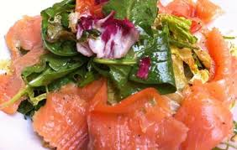Menu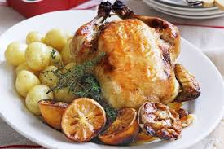
Sunday 19th April 2015

LUNCH MENU
Roast Chicken
Served with
Roast Potatoes, Baby Carrots and Savoy Cabbage
~~~~~~~~~~~~~~
For Dessert…..
Peach Tarte Tatin
Or
Chocolate Orange Trifle

TEA MENU
Smoked Salmon Salad
Or
Spring Rolls with Salad
~~~~~~~~~~~~~
For Dessert…..
Flap Jacks
Or
Morello Cherries with Cream

INFORMATION REGARDING ALLERGENS IS AVAILABLE ON REQUEST
The Larder Menu is always available – order as soon as possible to make life easier in the kitchen!!

